I-Robotics
Team 7320
Research Highlights

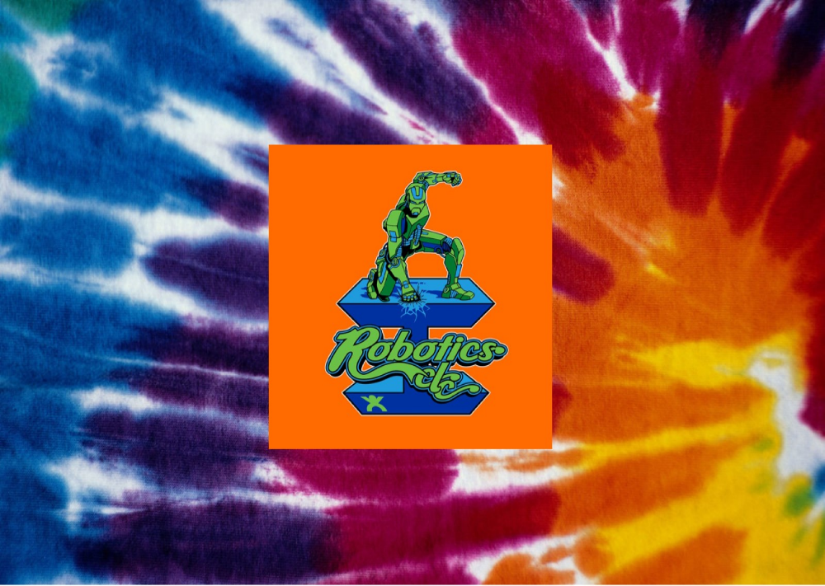

Table Of Contents

Page 1 - Research Questions & Resources

Page 2 - Camera Traps & Campaigns

Page 3 - Wes Ikezoe

Page 4 - Chicago Bikers

Page 5 - Gretchen Pencer

Page 6 - John Andrews

Page 7 – Other Research

Research Question
How can we improve the relationship between African Painted Dogs and Farmers?

Research Resources
- Gretchen Pencer
- Lee Stellakis
- Jordan Stellakis
- John Andrews
- Chicago Bikers
- Kelly Ulrich
- Wes Ikezoe
- Lincoln Zoo - Chicago,IL
- Potawatomi Zoo - South Bend, IN
- World Wide Web
- On-line Encyclopedia
- Library Resources

Our Innovative Solution

Camera Traps and Marketing Campaign

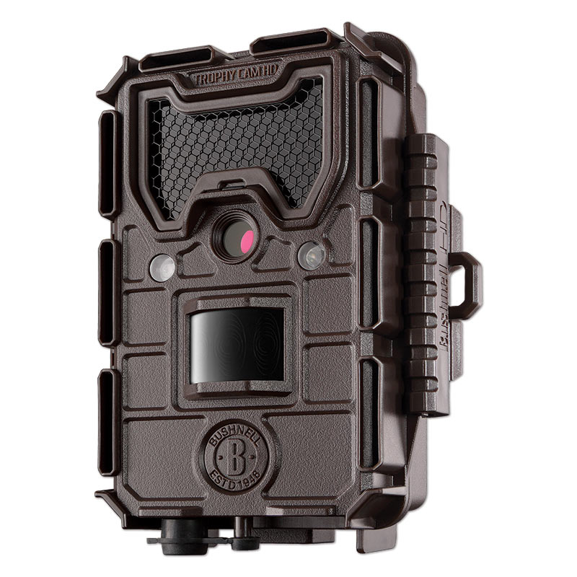

Camera Traps

For our innovative solution we decided to notify the farmers and put Camera Traps on their land. This would help them see which predators are really eating their cattle. Each camera trap will cost approximately $35.00.

Marketing Campaign

The other half of our innovative solution will be to set up a marketing campaign to help inform farmers that the African Painted Dog is not responsible for killing all of their cattle. This campaign will also show the farmers that the African Painted Dog is good for the environment and that they are not bad animals.

What We Learned From Wes Ikezoe:

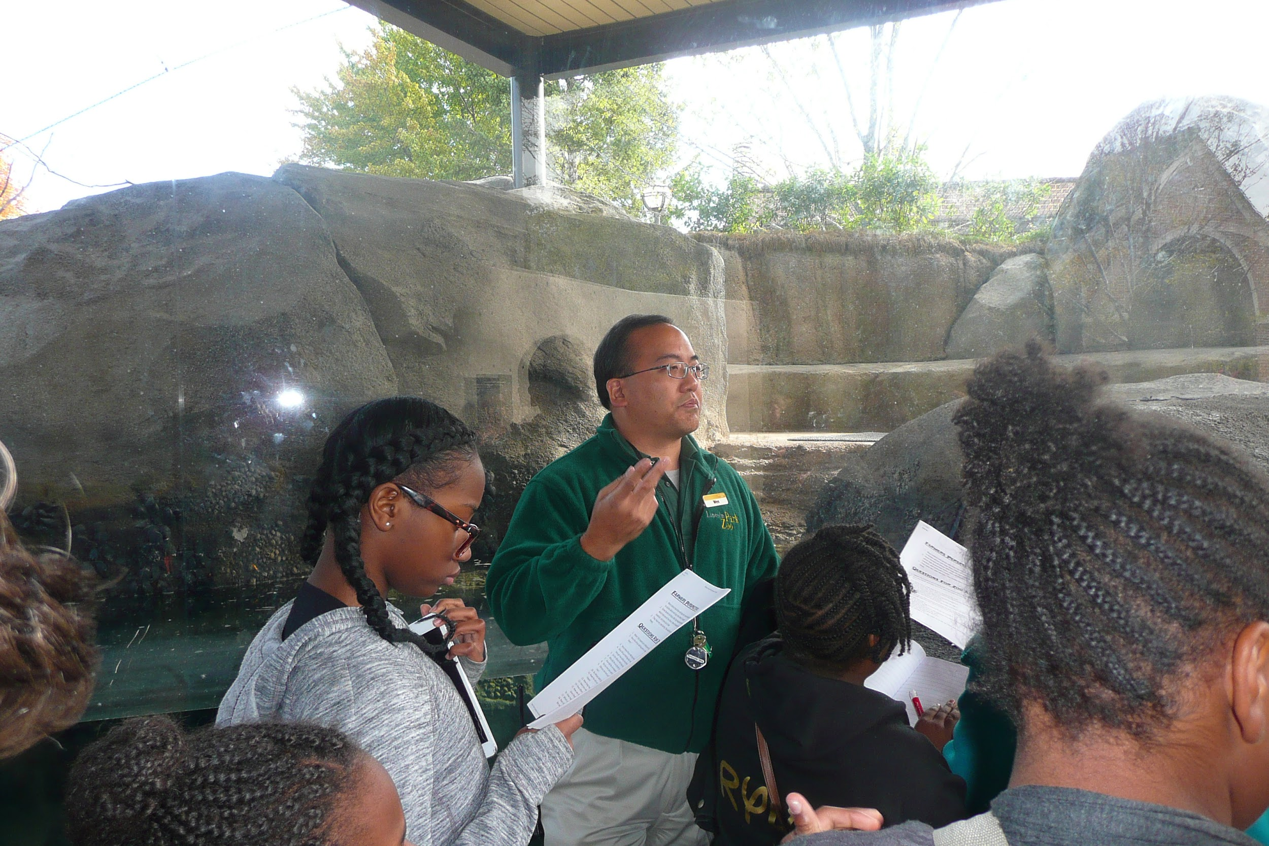

- He’s a volunteer at the Lincoln Park Zoo in Chicago
- We learned the process of taking care of painted dogs at the zoo
- We also learned that painted dogs can be put on Birth Control.
- We learned that more painted dogs were born in captivity.
- We learned that all African Painted Dogs currently in zoos were born in captivity. They were not taken from the wild.

What We Learned From Lee and Jordan Stellakis

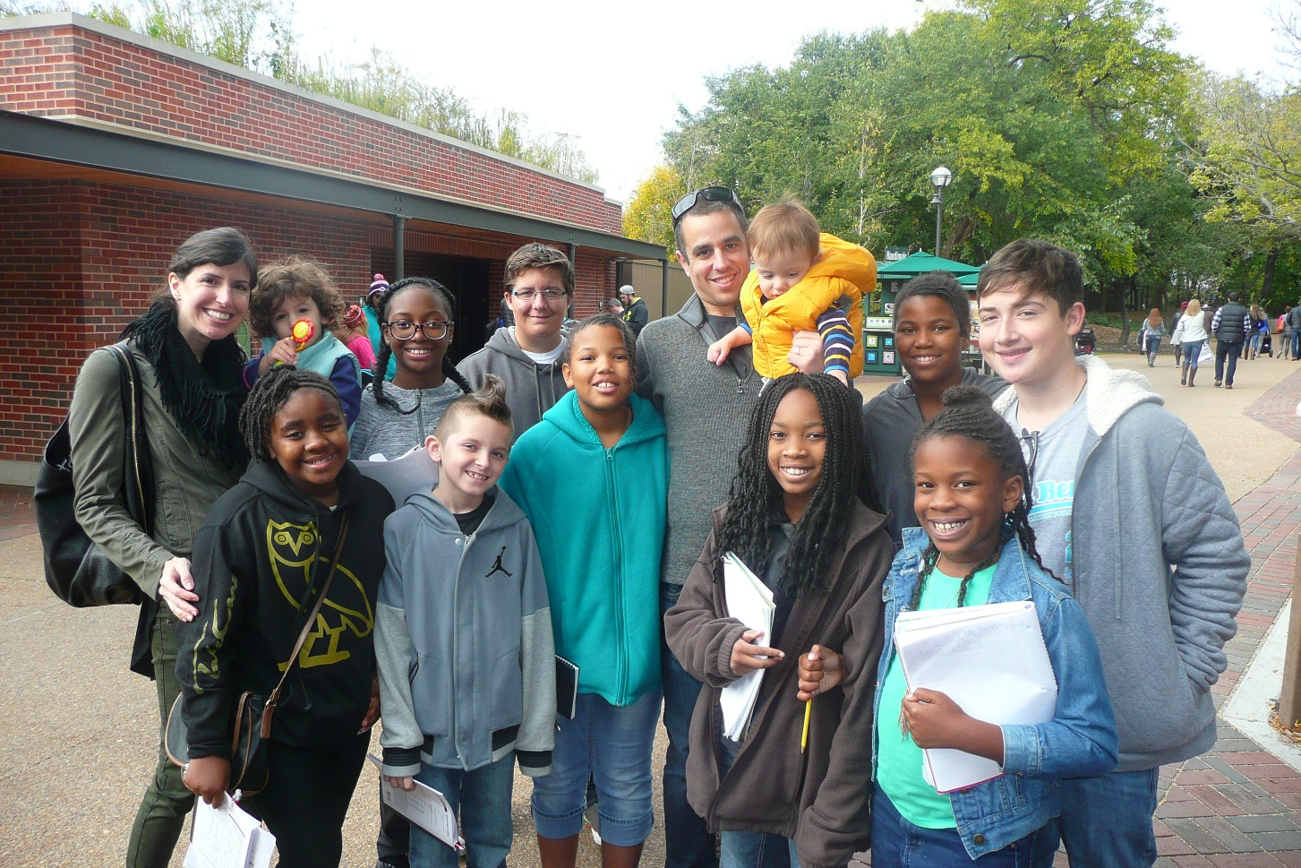

- We learned that the Chicago Bikers fund and support us in everything we do.
- We learned to be grateful because if it wasn't for them we wouldn’t be where we are today.
- The Chicago Bikers helped us with our innovative solution.
- For everything they’ve done for us we will learn to be thankful.
- We learned that without them we wouldn't have all the great opportunities we have.

What We learned from Gretchen Pencer

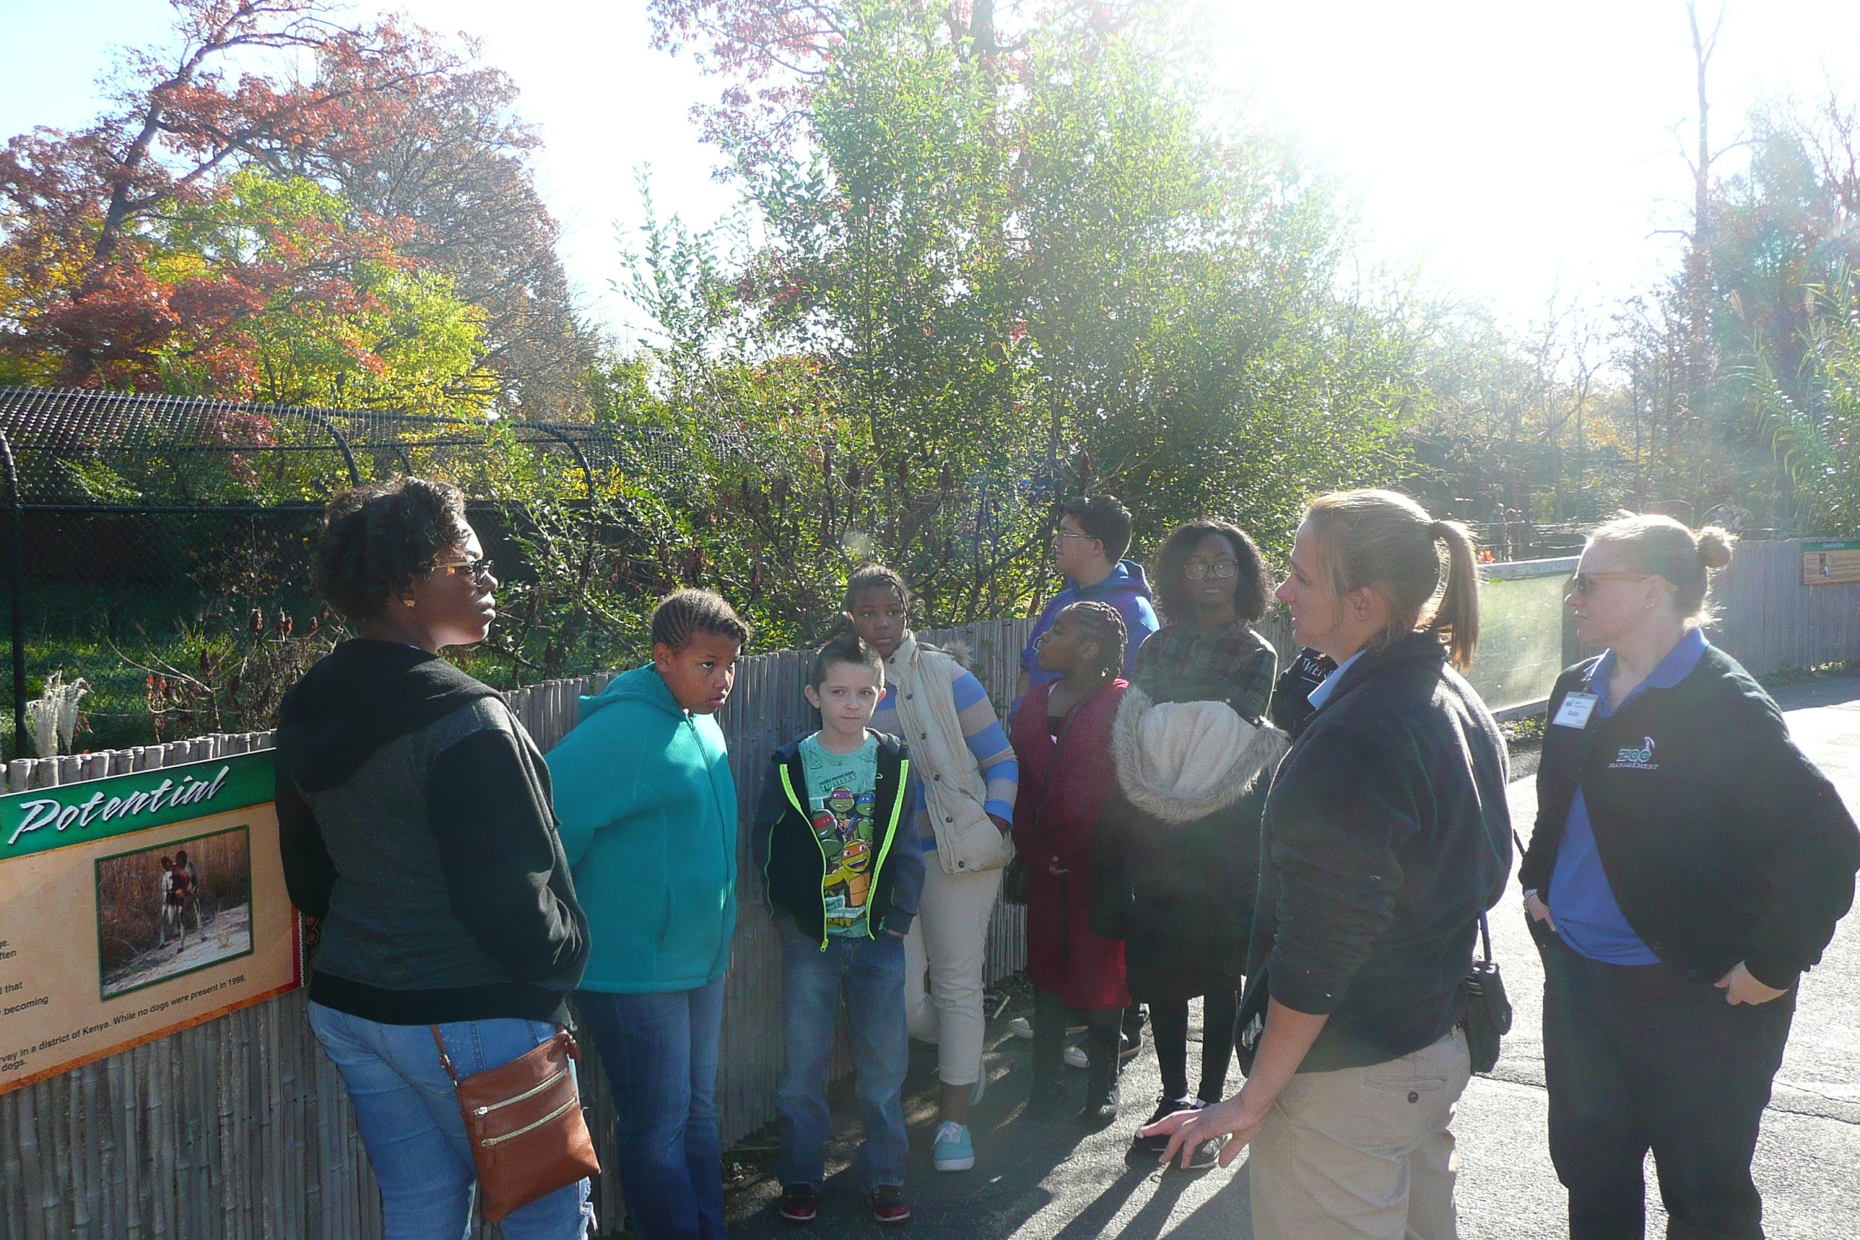

- We learned from Gretchen that The African Painted Dog’s scientific name is Mbwa Mwitu .
- We learned that African painted dogs mark their territory with urine .
- We learned that zookeepers control breeding so that closely related dogs do not breed together.
- We learned that African painted dogs’ cages have a lot of space to roam around; though it's not as much as they would have in the wild.

What We Learned From John Andrews

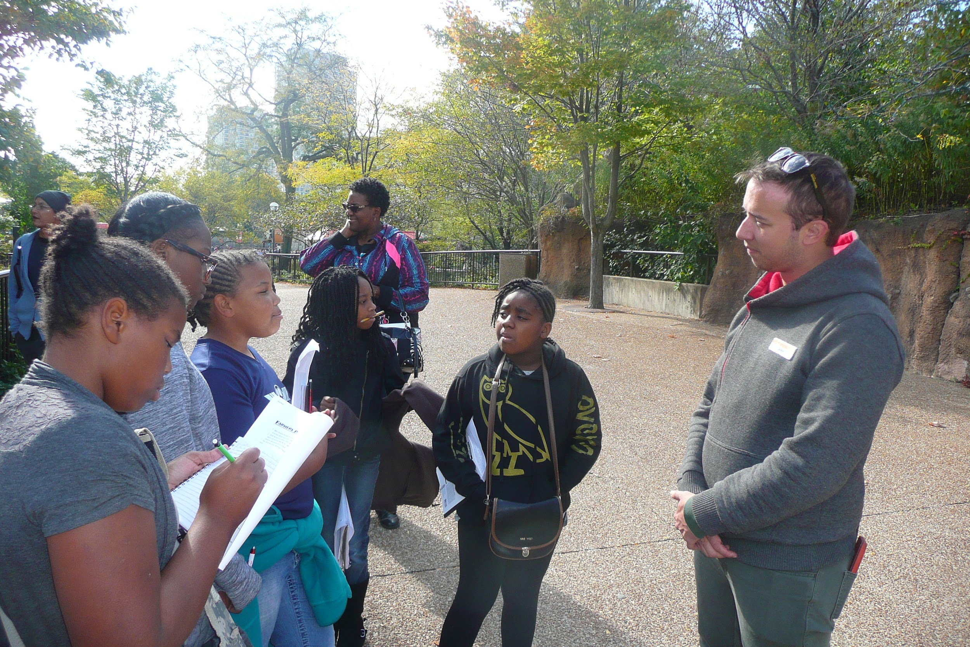

- We learned that When African painted Dogs first come to the zoo the people who work there have to make sure they don't have any diseases that are caused by pathogens.
- We learned that Zookeepers aren’t allowed to interact with the African painted Dogs unless they have a medical condition.
- We learned that African Painted Dogs mark their terrain with urine.
- We learned that African Painted Dogs not only suffer from being hurt by farmers but by many diseases.
- We learned that zookeepers control breeding so that closely related dogs do not breed together.

Other Things We Learned From Our Research

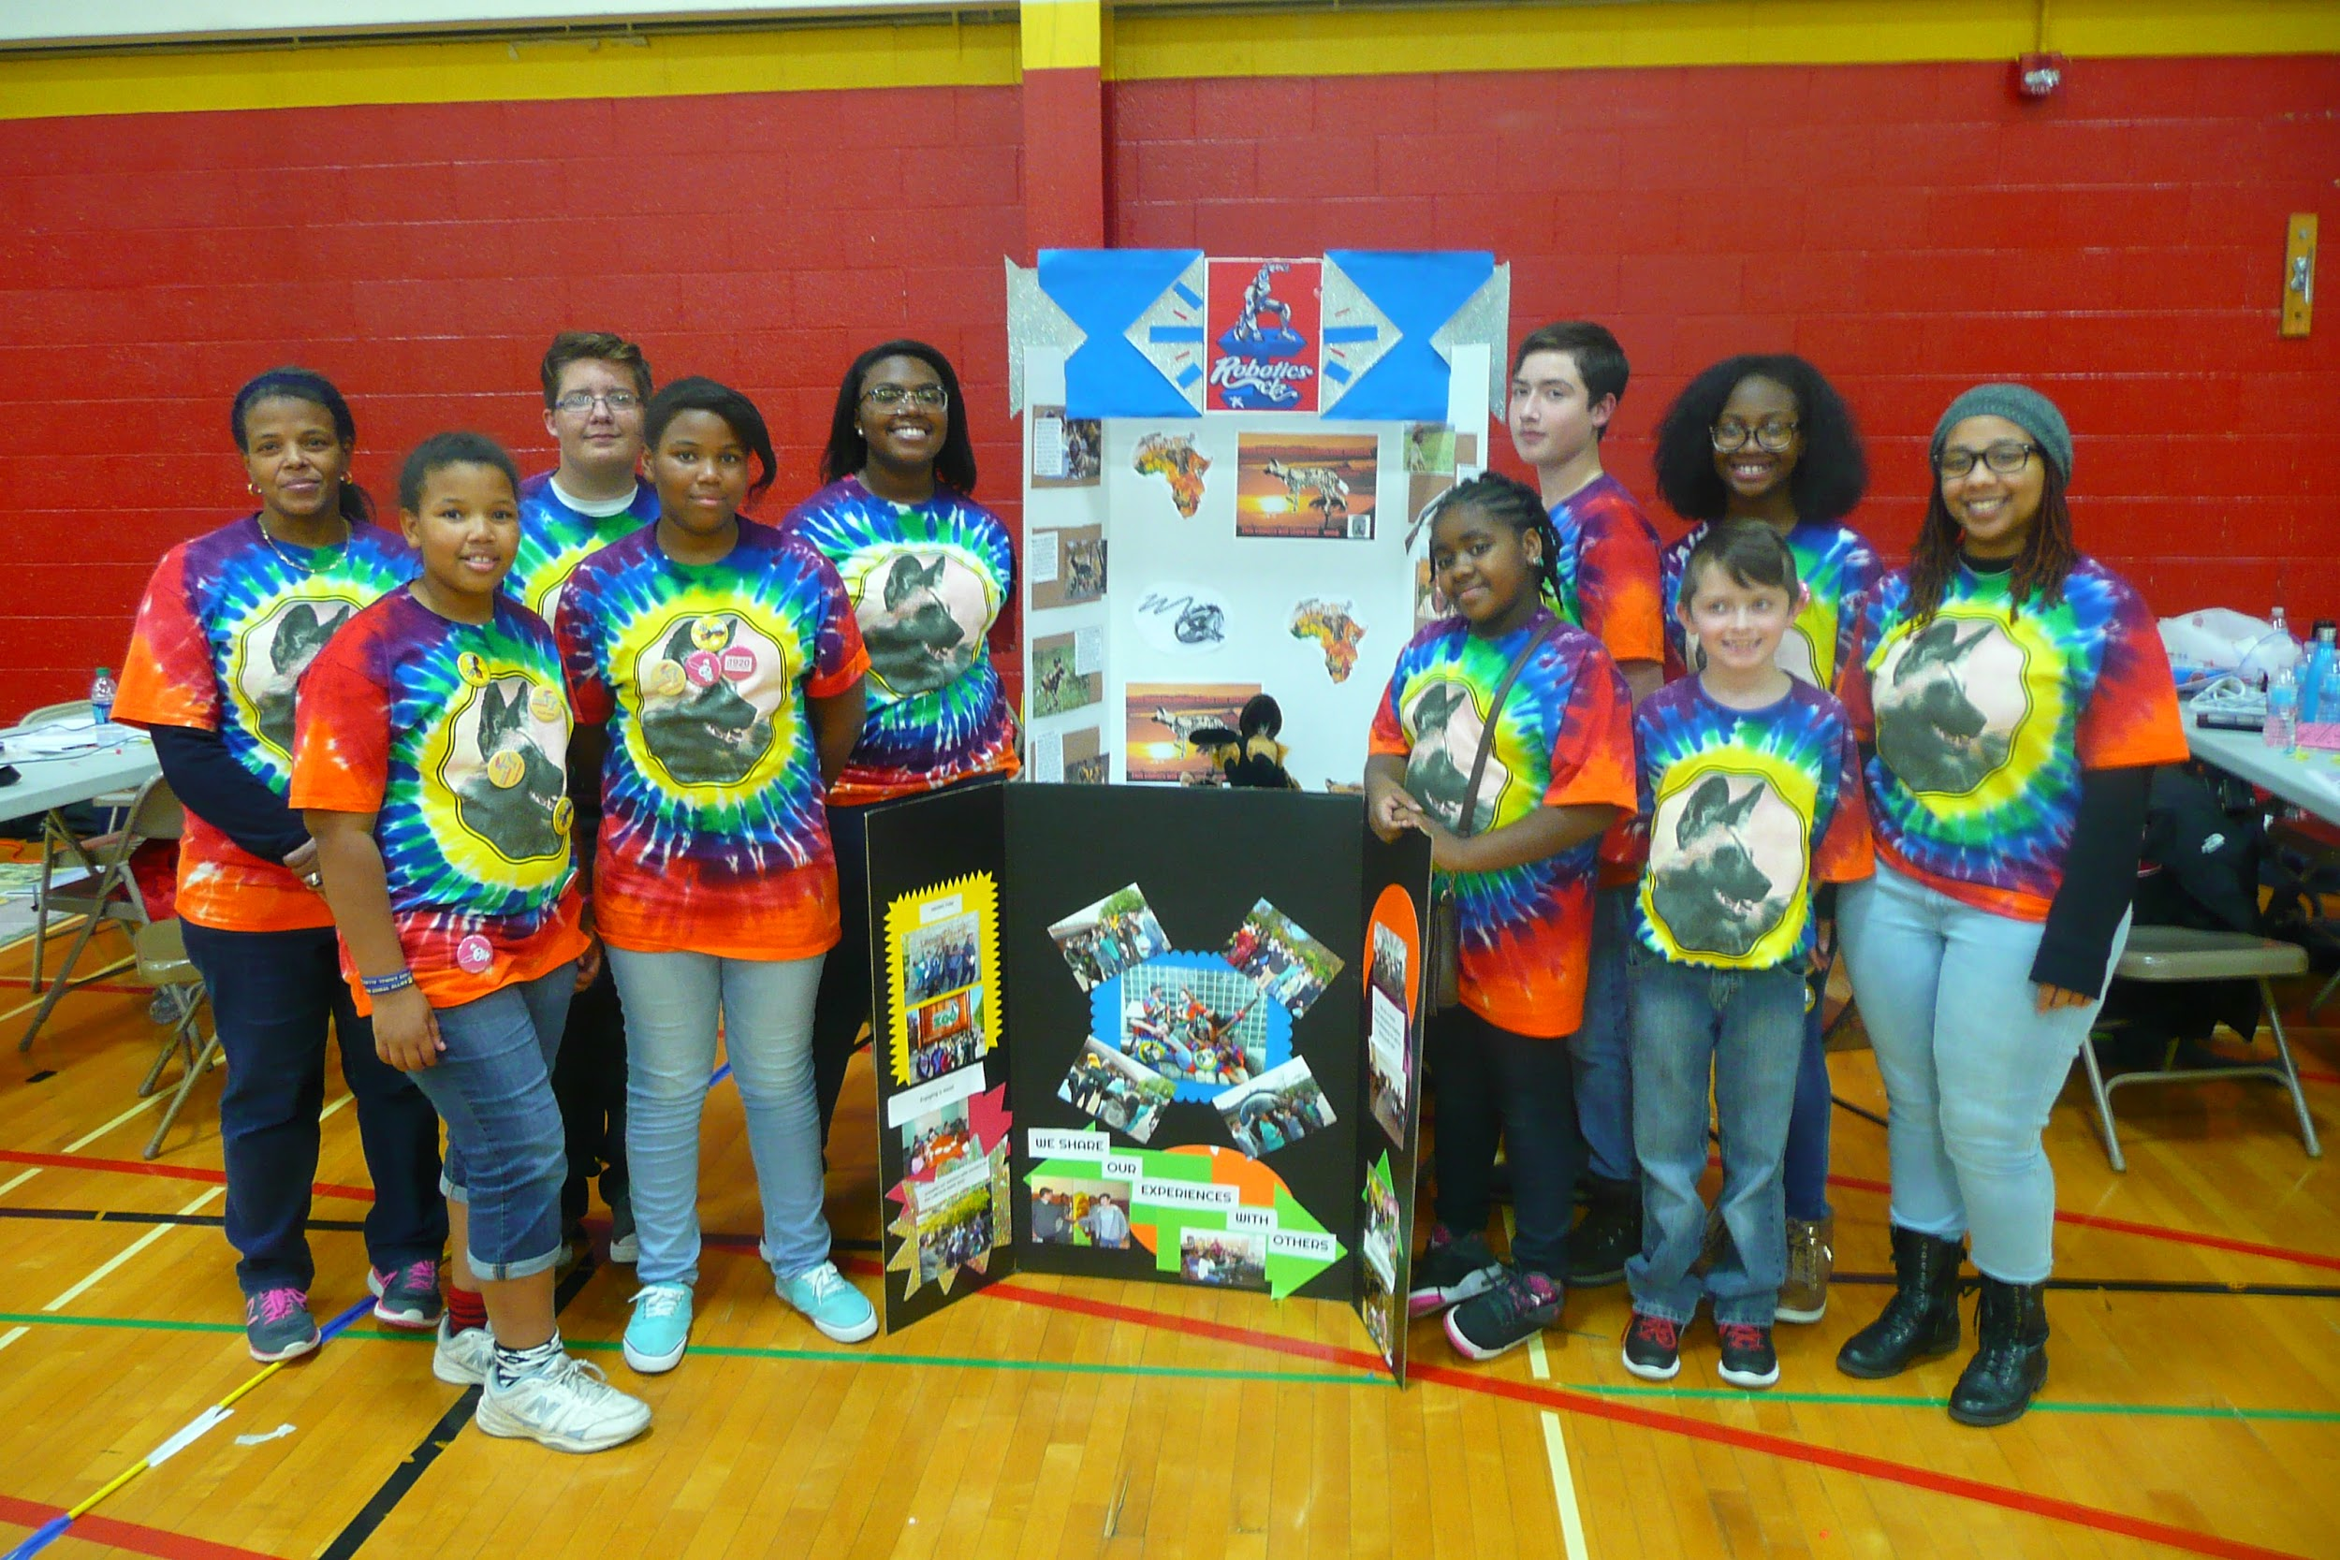

- We checked several websites that focused on the African Wild Dog and discovered what different organizations are doing to help African Painted Dogs.
- We learned that there are only 6,500 African Painted Dogs left in the wild.
- We learned that other predators are killing most of the farmers’ cattle in Africa. African Painted Dogs kill less than 2% of their cattle
- We learned that camera traps take pictures when it senses movement.

