I-Robotics
Team 7320
Technical Highlights

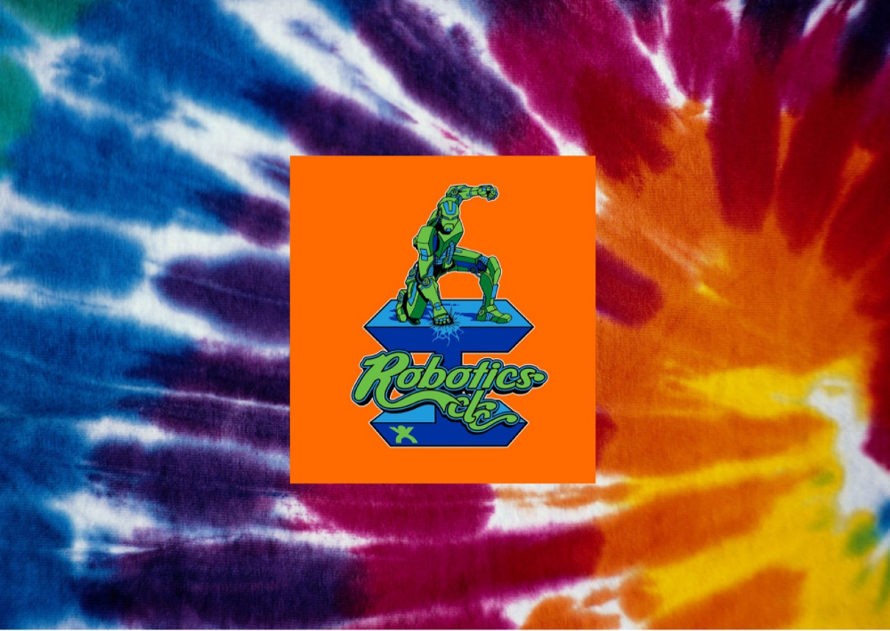

Dog

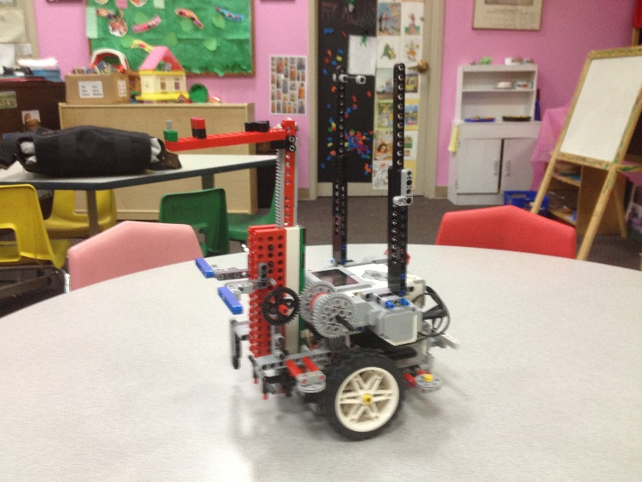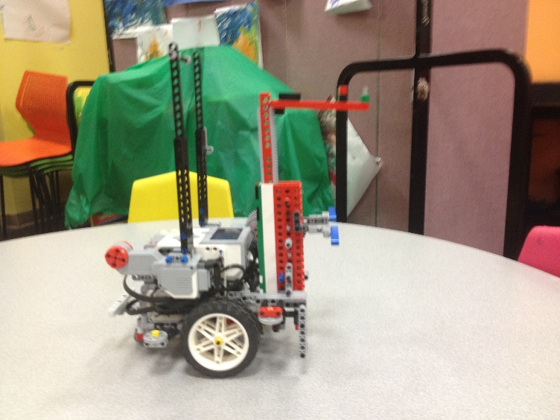

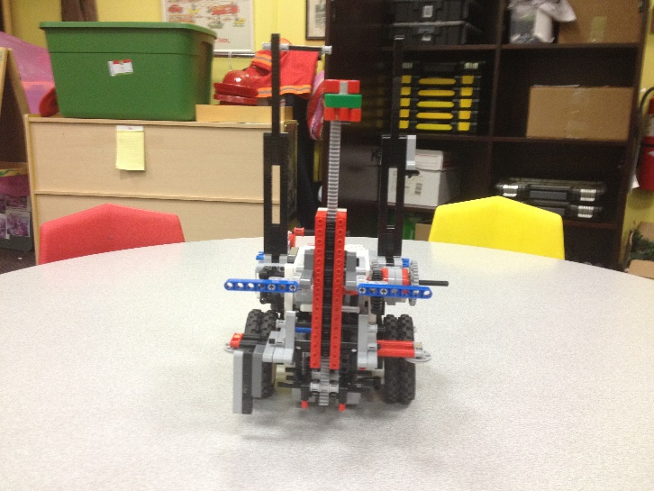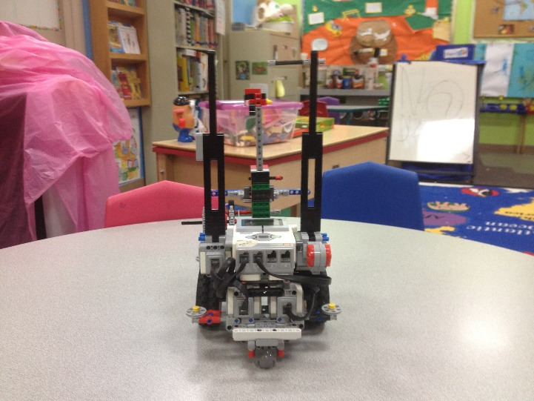

Two Light Sensors Four Motors
Four Wheels Side Guide Wheels
Steel Support Balls Fork Lift Type Attachment
Compact Design Passed the Drop Test!
Mission 1 -- Deliver Shark
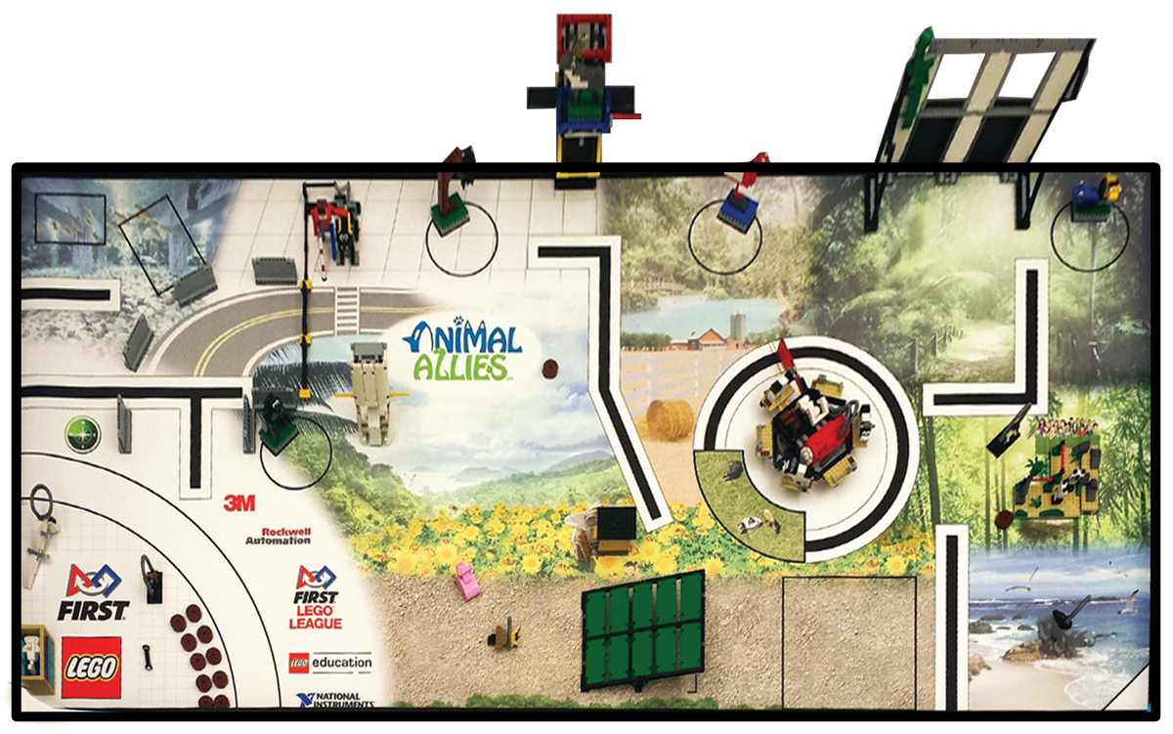

Mission 1 Attachments

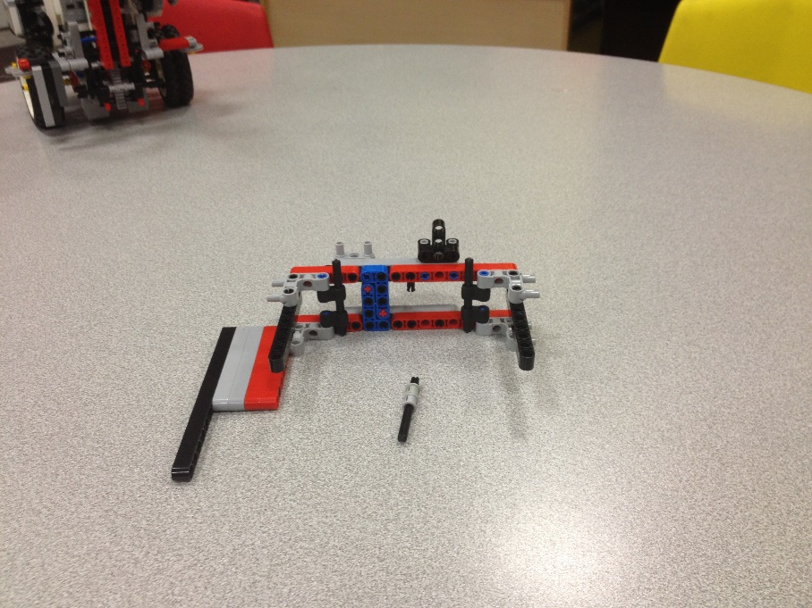
Mission 2 -- Grab Bee and Pig

Mission 2 Attachments

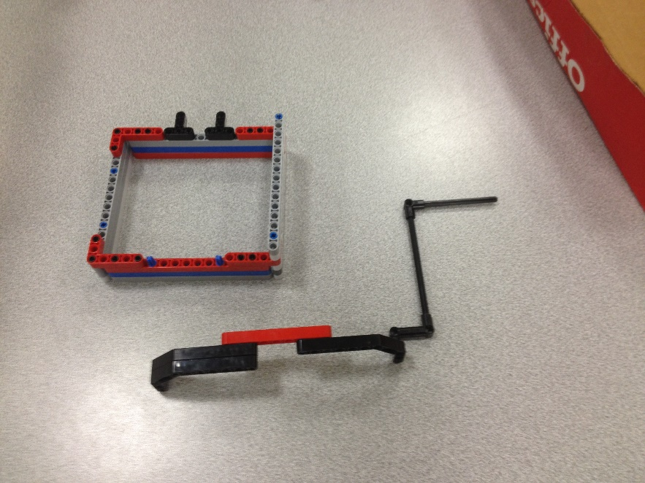
Mission 3 -- Activate Fence and Grab Food

Mission 3 Attachments

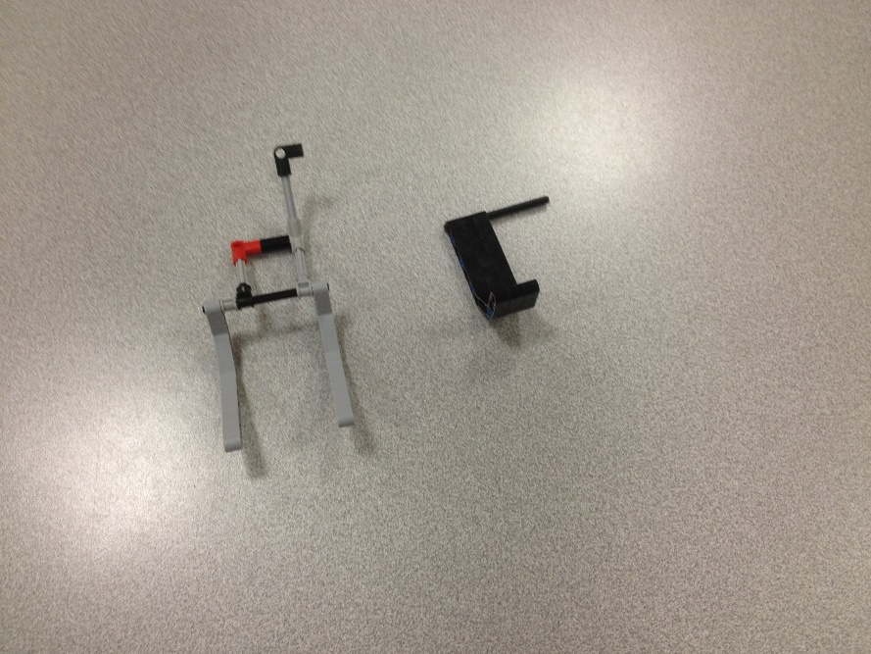
Mission 4 -- Deliver Food

Mission 4 Attachment

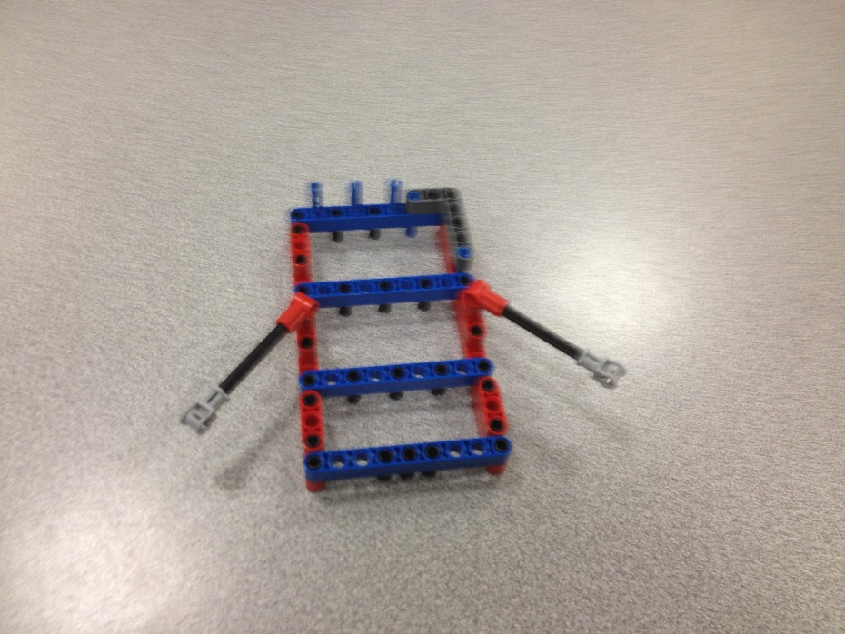
Mission 5 -- Milk / Researcher / P anda / Geiko/ Camera

Mission 5 Attachments
